Classification Analysis
Task 1
Kiara Angelys Ganger
Western Governors University
D 209 | DATA Mining 1

Part I: Research Question

Purpose of the Data Mining Report:

Proposed Question:
Can we predict which customers are at risk of churn using the Naïve Bayes classification method, to enable the telecom provider to proactively address potential customer loss?

Goal of the Data Analysis:
Goal: The goal of this analysis is to create a predictive model that can help identify customers who are likely to churn in the next month.
By using the Naïve Bayes Classification Method, I hope to create a model that can analyze multiple attributes and predict their churn probabilities. This will help the company create retention strategies to help reduce the churn rate and enhance retention.

Part II: Method Justification

Reason For Classification Method:

How Naïve Bayes Analyzes the Selected Data Set:
Naïve Bayes is a statistical classification method based on Bayes Theorem. When it comes to using large databases it has high accuracy, speed and a reliable algorithm. Naïve Bayes will analyze the data set by calculating the probability of the target class Churn given the observed feature values. The model will estimate the likelihood of each class (Churn or No Churn) for each feature (Awan, 2023)
The expected outcome is a model that assigns a probability score to each customer. Letting me know the likelihood of them churning out. The higher the score the more likely they are to churn.

Assumption of Naïve Bayes:
Summary of Assumption
- Independence Assumption:
Naïve Bayes assumes that the presence of a particular feature in a class is unrelated to the presence of any other feature. Known as the “Naïve” assumption (Naive Bayes Classifier in R Programming, 2024).

Packages, Libraries and Justifications:
Packages:
- readr:
Purpose – readr is used to read data from files on R, like CSV files
Justification – Ideally, I tend to like to use the base r package but for this task, readr reads files about 10x faster than the base r package. Jobs that run longer will have a progress bar which I won’t have with the base r package, and it doesn’t alter column names
- dplyr:
Purpose – dplyr have a set of functions that allow for data manipulation and data cleaning
Justification – This is useful for preparing the data for any kind of analysis. Due to its abilities to filter, select, and mutation datasets.
- ggplot2:
Purpose – ggplot2 is a data visualization package.
Justification – With ggplot2 I will be able to create visualize analysis to view patterns, trends and the distribution of the data
- caret:
Purpose – caret has the functions needed for complex regression and classification problems
Justification – With caret I can split the data into train and test groups, model training and create a evaluation model. This makes the model much easier and more standardized.
- e1071:
Purpose – Contains tools for implement Naïve Bayes Classifier and other machine learning algorithms
Justification – This package has the tools needed to complete this paper and build the churn prediction model.
- dummy:
Purpose – One Hot encoding
Justification – Converts categorical variables into a numeric format. dummy also gives each category its own column.
- car:
Purpose – Companion to Applied Regression (CAR) tools
Justification –is used for regression analysis. Its great for finding collinearity and will allow me to run the vif() function
- pROC:
Purpose – ROC curve analysis
Justification – Has tools for visualizing, smoothing, and comparing ROC curves

Part III:Data Preparation

Performing Data Preparation

Data Preprocessing Goal:
To tailor the data preparation process for the Naïve Bayes model, I will follow specific steps to ensure the data is ready for analysis. Such as handling missing data, removing outliers, and converting categorical variables into numeric format using one-hot encoding. Including the following -
Goal: for Native Bayes selecting relevant features that contribute significantly to the model's predictive power

Initial Data Set Variables
Variable | Type
Churn(target variable) | Categorical
Marital | Categorical
Gender | Categorical
Contract | Categorical
Internet Service | Categorical
Phone | Categorical
Multiple | Categorical
Online Security | Categorical
Online Backup | Categorical
Device Protection | Categorical
Tech Support | Categorical
Streaming TV | Categorical
Streaming Movies | Categorical
Paperless Billing | Categorical
Children | Numeric
Income | Numeric
Outage Sec Per week | Numeric
Yearly Equipment Failure | Numeric
Tenure | Numeric
Monthly Charge | Numeric
Bandwidth GB Year | Numeric

Data Preparation Steps
- Step 1:
- Install and or load the packages and libraries
1. # Install Packages
2. install.packages("readr")
3. install.packages("dplyr")
4. install.packages("ggplot2")
5. install.packages("caret")
6. install.packages("e1071")
7. install.packages("dummy")
8. install.packages("car")
9. # Load necessary libraries
10. library(readr) # For reading data
11. library(dplyr) # For data manipulation
12. library(ggplot2) # For data visualization
13. library(caret) # For model training and evaluation
14. library(e1071) # For Naive Bayes classifier
15. library(dummy) # For one-hot encoding
16. library(car) # For VIF calculation
17. library(pROC) # For ROC curve analysis
18.
- Step 2:
- Load and inspect the data – Here I loaded the dataset using readr, and reviewed the structure
1. # Load the dataset
2. churn <- read_csv('C:/Users/kiara/OneDrive/WGU MSDA/D209/churn_clean.csv')
3. View(churn)
4. # Inspect the data
5. head(data)
6. str(data)
7.
- Step 3:
- Check for and remove any null values, missing data, duplicates, and outliers
1. # Inspect the data for missing, duplicated or outliers
2. sum(is.na(churn))
3. sum(duplicated(churn))
4. # Function to identify and remove outliers using IQR method
5. remove_outliers <- function(df, var) {
6. Q1 <- quantile(df[[var]], 0.25, na.rm = TRUE)
7. Q3 <- quantile(df[[var]], 0.75, na.rm = TRUE)
8. IQR <- Q3 - Q1
9. lower_bound <- Q1 - 1.5 * IQR
10. upper_bound <- Q3 + 1.5 * IQR
11. df <- df[df[[var]] >= lower_bound & df[[var]] <= upper_bound, ]
12. return(df)
13. }
14.
15. # Apply the function to numeric variables
16. numeric_vars <- c('Children', 'Income', 'Outage_sec_perweek', 'Yearly_equip_failure', 'Tenure', 'MonthlyCharge', 'Bandwidth_GB_Year')
17.
18. for (var in numeric_vars) {
19. churn <- remove_outliers(churn, var)
20. }
21.
- Step 4:
- Preform Label Encoding on Yes/No Variables and One Hot on Variables with 3 or more options
1. # Apply label encoding to other categorical variables
2. churn <- churn %>%
3. mutate(
4. Churn = ifelse(Churn == "Yes", 1, 0),
5. Phone = ifelse(Phone == "Yes", 1, 0),
6. Multiple = ifelse(Multiple == "Yes", 1, 0),
7. PaperlessBilling = ifelse(PaperlessBilling == "Yes", 1, 0),
8. OnlineSecurity = ifelse(OnlineSecurity == "Yes", 1, 0),
9. OnlineBackup = ifelse(OnlineBackup == "Yes", 1, 0),
10. DeviceProtection = ifelse(DeviceProtection == "Yes", 1, 0),
11. TechSupport = ifelse(TechSupport == "Yes", 1, 0),
12. StreamingTV = ifelse(StreamingTV == "Yes", 1, 0),
13. StreamingMovies = ifelse(StreamingMovies == "Yes", 1, 0)
14. )
15. # One Hot Encode
16. internet_dummies <- model.matrix( ~ InternetService - 1, data = churn)
17. churn <- cbind(churn, internet_dummies)
18. churn <- churn %>% select(-InternetService)
19.
20. gender_dummies <- model.matrix( ~ Gender - 1, data = churn)
21. churn <- cbind(churn, gender_dummies)
22. churn <- churn %>% select(-Gender)
23.
24. marital_dummies <- model.matrix( ~ Marital - 1, data = churn)
25. churn <- cbind(churn, marital_dummies)
26. churn <- churn %>% select(-Marital)
27.
28. contract_dummies <- model.matrix( ~ Contract - 1, data = churn)
29. churn <- cbind(churn, contract_dummies)
30. churn <- churn %>% select(-Contract)
31.
- Step 5:
- Rename the dummy columns
1. # Rename the column for better coding
2. churn <- churn %>%
3. rename(
4. InternetService_None = `InternetServiceNone`,
5. InternetService_Fiber_Optic = `InternetServiceFiber Optic`,
6. InternetService_DSL = `InternetServiceDSL`,
7. Contract_Monthly = 'ContractMonth-to-month',
8. Contract_One_Year = 'ContractOne year',
9. Contract_Two_Year = 'ContractTwo Year',
10. Gender_Female = 'GenderFemale',
11. Gender_Male = 'GenderMale',
12. Gender_Nonbinary = 'GenderNonbinary',
13. Marital_Divorced = 'MaritalDivorced',
14. Marital_Married = 'MaritalMarried',
15. Marital_Never_Married = 'MaritalNever Married',
16. Marital_Separated = 'MaritalSeparated',
17. Marital_Widowed = 'MaritalWidowed'
18. )
19.
- Step 6:
- Select variables for model dataset by creating a subset
1. # Subset of the Dataset with the variables for my initial model -1 dummy variable
2. variables_used <- c(
3. "Churn",
4. "Children",
5. "Income",
6. "Outage_sec_perweek",
7. "Yearly_equip_failure",
8. "Phone",
9. "Multiple",
10. "OnlineSecurity",
11. "OnlineBackup",
12. "DeviceProtection",
13. "TechSupport",
14. "StreamingTV",
15. "StreamingMovies",
16. "PaperlessBilling",
17. "Tenure",
18. "MonthlyCharge",
19. "Bandwidth_GB_Year",
20. "InternetService_DSL",
21. "InternetService_Fiber_Optic",
22. "Gender_Female",
23. "Gender_Male",
24. "Marital_Divorced",
25. "Marital_Married",
26. "Marital_Never_Married",
27. "Marital_Separated",
28. "Contract_Monthly",
29. "Contract_One_Year"
30. )
31. task_1 <- churn[variables_used]
32. View(task_1)
33.
- Step 7:
- Naïve Bayes assumes all features are independent from one another, but checking for correlation can help the stability of the model. Here I am checking for correlation:
1. ini_mod <- glm(
2. Churn ~ .,
3. family = "binomial",
4. data = task_1
5. )
6. print(ini_mod)
7. vif(ini_mod)
8.
9. ini_mod2 <- glm(
10. Churn ~ Children + Income + Outage_sec_perweek + Yearly_equip_failure + Phone + Multiple +
11. OnlineSecurity + OnlineBackup + DeviceProtection + TechSupport + StreamingTV + StreamingMovies +
12. PaperlessBilling + Tenure + MonthlyCharge + InternetService_DSL + InternetService_Fiber_Optic +
13. Gender_Female + Gender_Male + Marital_Divorced + Marital_Married + Marital_Never_Married +
14. Marital_Separated + Contract_Monthly + Contract_One_Year,
15. family = "binomial",
16. data = task_1
17. )
18. print(ini_mod2)
19. vif(ini_mod2)
20.
21. ini_mod3 <- glm(
22. Churn ~ Children + Income + Outage_sec_perweek + Yearly_equip_failure + Phone + Multiple +
23. OnlineSecurity + OnlineBackup + DeviceProtection + TechSupport + StreamingTV + StreamingMovies +
24. PaperlessBilling + Tenure + InternetService_DSL + InternetService_Fiber_Optic +
25. Gender_Female + Gender_Male + Marital_Divorced + Marital_Married + Marital_Never_Married +
26. Marital_Separated + Contract_Monthly + Contract_One_Year,
27. family = "binomial",
28. data = task_1
29. )
30. print(ini_mod3)
31. vif(ini_mod3)
32.
33. ini_mod4 <- glm(
34. Churn ~ Children + Income + Outage_sec_perweek + Yearly_equip_failure + Phone + Multiple +
35. OnlineSecurity + OnlineBackup + DeviceProtection + TechSupport + StreamingTV + StreamingMovies +
36. PaperlessBilling + Tenure + InternetService_DSL + InternetService_Fiber_Optic +
37. Gender_Female + Marital_Divorced + Marital_Married + Marital_Never_Married +
38. Marital_Separated + Contract_Monthly + Contract_One_Year,
39. family = "binomial",
40. data = task_1
41. )
42. print(ini_mod4)
43. vif(ini_mod4)
44.
In the initial run, Bandwidth GB Year came back with a vif of 738.07. So, I removed it and ran it again. This time the next highest score was Monthly Charge with 26.21. The next one was Gender Male which after removal balanced out the model.
- Step 8:
- Drop unneeded columns and save the update
1. variables_used <- c(
2. "Churn",
3. "Children",
4. "Income",
5. "Outage_sec_perweek",
6. "Yearly_equip_failure",
7. "Phone",
8. "Multiple",
9. "OnlineSecurity",
10. "OnlineBackup",
11. "DeviceProtection",
12. "TechSupport",
13. "StreamingTV",
14. "StreamingMovies",
15. "PaperlessBilling",
16. "Tenure",
17. "InternetService_DSL",
18. "InternetService_Fiber_Optic",
19. "Gender_Female",
20. "Marital_Divorced",
21. "Marital_Married",
22. "Marital_Never_Married",
23. "Marital_Separated",
24. "Contract_Monthly",
25. "Contract_One_Year"
26. )
27. task_1 <- task_1[variables_used]
28. write_csv(task_1, "C:/Users/kiara/OneDrive/WGU MSDA/D209/task_1.csv")
29. task_1 <- read_csv("C:/Users/kiara/OneDrive/WGU MSDA/D209/task_1.csv")
30. View(task_1)
31.

Clean data set:
Please see file: task_1.csv

Part IV Analysis

Data Analysis and Report

Splitting the Data
In this step I split the data set into training and testing datasets. This way I can evaluate the models
performance on unseen data.
Code for splitting the data:
1. # Set seed for reproducibility
2. set.seed(123)
3.
4. # Split the data into training (70%) and testing (30%) sets
5. trainIndex <- createDataPartition(task_1$Churn, p = .8, list = FALSE, times = 1)
6. trainData <- task_1[trainIndex, ]
7. testData <- task_1[-trainIndex, ]
8.
9. # Save the training and testing datasets
10. write_csv(trainData, "C:/Users/kiara/OneDrive/WGU MSDA/D209/trainData.csv")
11. write_csv(testData, "C:/Users/kiara/OneDrive/WGU MSDA/D209/testData.csv")
12.
Code to verify the split
1. # Load the saved files to verify
2. trainData <- read_csv("C:/Users/kiara/OneDrive/WGU MSDA/D209/trainData.csv")
3. testData <- read_csv("C:/Users/kiara/OneDrive/WGU MSDA/D209/testData.csv")
4.
5. # Ensure the data is correctly loaded
6. print(head(trainData))
7. print(head(testData))
8.
- Please see files
- traindata.csv
- testdata.csv

Analysis Technique and Intermediate Calculations:
- Analysis Technique
For this analysis I used the Naïve Bayes classifier, because it is a simple yet effective algorithm for binary classification. It is also extremely useful when using large datasets. First, I split the data into 80% training and 20% testing. This will ensure I train on a substantial portion on the data. The model was trained using all the chosen variables to predict the target variable Churn. I had predictions made on the test data to evaluate the model’s performance. Then ran a confusion matrix to evaluate the model’s performance in terms of accuracy, sensitivity, and other relevant metrics.
- Screenshots
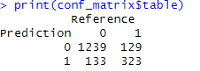
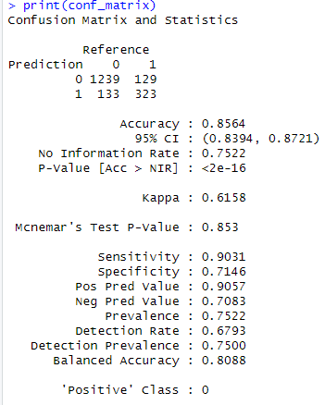

Code Used:
1. task_1 <- read_csv("C:/Users/kiara/OneDrive/WGU MSDA/D209/task_1.csv")
2. View(task_1)
3.
4. # Set seed for reproducibility
5. set.seed(123)
6.
7. # Split the data into training (70%) and testing (30%) sets
8. trainIndex <- createDataPartition(task_1$Churn, p = .8, list = FALSE, times = 1)
9. trainData <- task_1[trainIndex, ]
10. testData <- task_1[-trainIndex, ]
11.
12. # Save the training and testing datasets
13. write_csv(trainData, "C:/Users/kiara/OneDrive/WGU MSDA/D209/trainData.csv")
14. write_csv(testData, "C:/Users/kiara/OneDrive/WGU MSDA/D209/testData.csv")
15.
16. # Load the saved files to verify
17. trainData <- read_csv("C:/Users/kiara/OneDrive/WGU MSDA/D209/trainData.csv")
18. testData <- read_csv("C:/Users/kiara/OneDrive/WGU MSDA/D209/testData.csv")
19.
20. # Ensure the data is correctly loaded
21. print(head(trainData))
22. print(head(testData))
23.
24. # Train the Naive Bayes model
25. nb_model <- naiveBayes(Churn ~ ., data = trainData)
26.
27. # Predict on the test data
28. predictions <- predict(nb_model, testData)
29.
30. # Ensure that both predictions and actual values are factors with the same levels
31. testData$Churn <- factor(testData$Churn)
32. predictions <- factor(predictions, levels = levels(testData$Churn))
33.
34. # Evaluate the model performance
35. conf_matrix <- confusionMatrix(predictions, testData$Churn)
36.
37. # Print the confusion matrix and its table
38. print(conf_matrix)
39. print(conf_matrix$table)
40.

Part V: Data Summary and Implications

Summarize your analysis

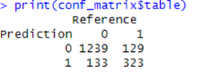
Explanation of Model
Based on the matrix table I created in section D2,
and a combination of Using the R code provided in
the power point for class D209 Task1. I imputed my
numbers to match my confusion matrix and ran the following codes to calculate the following:
- Accuracy
1. # Calculate and print the accuracy of the model
2. accuracy <- conf_matrix$overall['Accuracy']
3. print(paste("Accuracy: ", round(accuracy * 100, 2), "%", sep = ""))
4.
$$Accuracy=\frac{ 1239+323}{1239+129+133+323}=\frac{1562}{1824}≈0.8564$$
The accuracy of the model is:
"Accuracy: 85.64%"
- Sensitivity and Specificity
1. # Calculate and print the sensitivity and specificity
2. sensitivity <- conf_matrix$byClass['Sensitivity']
3. specificity <- conf_matrix$byClass['Specificity']
4. print(paste("Sensitivity: ", round(sensitivity * 100, 2), "%", sep = ""))
5. print(paste("Specificity: ", round(specificity * 100, 2), "%", sep = ""))
6.
$$Sensitivity= \frac{1239}{1239+133}=\frac{1239}{1372}≈0.9031$$
The sensitivity of the model is 90.31%
"Sensitivity: 90.31%"
$$Specificity= \frac{323}{323+129}=\frac{323}{452}≈0.7146$$
The specificity of the model is
"Specificity: 71.46%"
- Area under the curve
1. # Calculate and print the AUC
2. predictions_prob <- predict(nb_model, testData, type = "raw")
3. roc_obj <- roc(testData$Churn, predictions_prob[, 2])
4. auc_value <- auc(roc_obj)
5. print(paste("AUC: ", round(auc_value, 4)))
6.
7. # Plot the ROC curve
8. plot(roc_obj, col = "#1c61b6", main = "ROC Curve for Naive Bayes Model")
9. abline(a = 0, b = 1, col = "red", lty = 2) # Add a diagonal line for reference
10.
The area under the curve of the model is
"AUC: 0.9169"
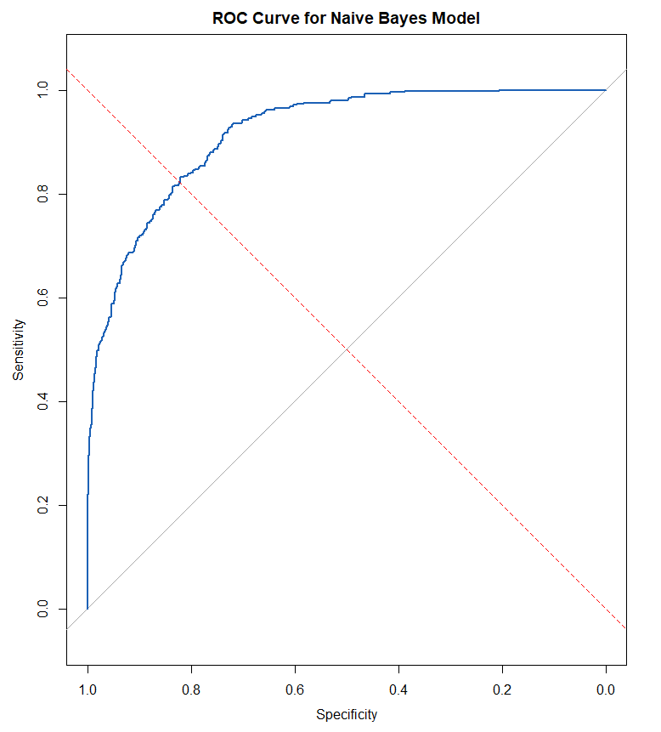
(Elleh, 2023)

Discussion of my results and the Implications
- Results
Accuracy: 85.64%
Sensitivity: 90.31%
Specificity: 71.46%
AUC: 0.9169
- Implications
The model has a high accuracy and sensitivity score, meaning that the model is effective at identifying customers who are likely to Churn. The high sensitivity means that the model correctly identifies a large proportion of actual churners.
On the other hand, the model has a low specificity. This is an indication that the model is not as effective in identifying customers that are non-churners, giving false positives. The AUC’s score of 0.9169 supports the model’s excellent performance in distinguishing between the two classes even with the low specificity score. I believe that using more labeled data for training could help the model. It will allow it to learn to better distinguish between churn and non-churn customers, improving the overall specificity rating.

One Limitation
One limitation that sticks out from the analysis is the possible imbalance in the dataset. Given that the numbers of non-churn customers significantly outweigh the number of churn customers the model might not give a good reading on how customers are labeled. For example, the model may perform well in accuracy, it may not perform as well in specificity. Leading to false negatives where non-churning customers are incorrectly labeled as churners.

Recommended Course of Action
Based on the analysis and the model’s performance I can recommend the following:
- Model Improvement
I recommend trying to improve the imbalance of the data set. Using techniques like SMOTE (Synthetic Minority Over-sampling Technique). SMOTE is a popular algorithm used to address the problem of class imbalance in machine learning (N. V. Chawla, 2011). Or they can try adjusting class weights, either could improve the model's performance. They can also try increasing the amount of labeled data for churn cases. This can help improve the models learning and performance
- Customer Retention
To help retain customers I recommend they use the model to identify customers at high risk of churning. Creating discounts or rewards to intrigue them into staying or switching over to a better service that would better fit their family needs. They can do this by reviewing the survey response and other personal information such as if they have kids or are married. To create a more personalized offer for these customers.
Trying this might help the company reduce churn rates and the performance of the customer experience, while also improving the performance of the model.

Part VI: Demonstration

Panopto Video
- Link:
Ganger D209 Task1 (panopto.com)

Code Source
Elleh, F. (2023, August 15). Data Science Team. Retrieved from WGU SharePoint: https://westerngovernorsuniversity.sharepoint.com/sites/DataScienceTeam/Shared%20Documents/Forms/AllItems.aspx?isAscending=true&id=%2Fsites%2FDataScienceTeam%2FShared%20Documents%2FGraduate%20Team%2FD209%2FStudent%20Facing%20Resources&sortField=LinkFilena

References
Awan, A. A. (2023, March). Naive Bayes Classification Tutorial using Scikit-learn. Retrieved from datacamp: https://www.datacamp.com/tutorial/naive-bayes-scikit-learn
N. V. Chawla, K. W. (2011, June 09). SMOTE: Synthetic Minority Over-sampling Technique. Retrieved from Cornell University: https://arxiv.org/abs/1106.1813
Naive Bayes Classifier in R Programming. (2024, April 12). Retrieved from Geeks For Geeks: https://www.geeksforgeeks.org/naive-bayes-classifier-in-r-programming/

